**A PROJECT REPORT ON**

**“Simulating a monostatic Pulse Radar for Range and velocity estimations”**

**Submitted in partial fulfilment of the Requirements**

**For the degree of**

**Master of Science**

**(Electronic Science)**

**By**

***Apoorv Tomar***

***Roll No-3852***

***Under the guidance of***

***Mr. Amit Birwal***

***(Assistant Professor)***



**DEPARTMENT OF ELECTRONIC SCIENCE**

**(UNIVERSITY OF DELHI, SOUTH CAMPUS)**

**Benito Juarez Road, New Delhi, India 11021**

**June 2020**



DEPARTMENT OF ELECTRONIC SCIENCE

University of Delhi, South Campus

Benito Juarez road, New Delhi 110021, India

***CERTIFICATE***

This is to certify that **Mr. Apoorv Tomar,** student of University of Delhi has successfully completed his project work entitled **“Simulating a monostatic Pulse Radar for Range and velocity estimations”** under the partial fulfillment of his Master’s degree (MSc) in Electronics from the Department of Electronic Science, **University of Delhi, South Campus, New Delhi**. This report embodies original work of the candidate. It has been carried out under our guidance and supervision and is to the satisfaction of the department.

**Mr. Amit Birwal** **Dr. P. Koteswara Rao** Assistant ProfessorAssistant Professor  **(Project Guide) (Project Coordinator)** Department Of Electronic Science, Department Of Electronic Science, University of Delhi, South Campus. University of Delhi, South Campus.

**Prof. Mridula Gupta** ( **Head Of Department )** Department Of Electronic Science, University of Delhi, South Campus.

*Candidate’s Declaration*

I hereby declare that the project entitled “**Simulating a monostatic Pulse Radar for Range and velocity estimations*”***, is carried out by me during the month January 2020 to June 2020 in partial fulfillment of the award of ***Master of Science*** with specialization in ***Electronics Science*** from ***Department of Electronic Science,*** ***University of Delhi, South Campus***, New Delhi, India. I have not submitted the same to any other University or organization for the award of any other degree.

Place: New Delhi **Apoorv Tomar**

Date: **Roll No-3852**

ACKNOWLEDGEMENT

First and foremost, I thank God, the almighty for providing me this opportunity and granting

me the capability to proceed successfully. This report appears in its current form due to the

assistance and guidance of several people. I would therefore like to offer my sincere thanks to

all of them.

The main guiding light who lit my days during the project work was my Guide Mr Amit

Birwal. His constant support and encouragement helped me to find my way in the most

difficult situations. His lighthearted words, voice and suggestions lifted all burdens and made

my work easier. His immense knowledge was always available to my curious mind.

Next, I pay my sincere thanks to my parents and sister for always being supportive. They

provided me the atmosphere wherein I could proceed with my writing calmly. They were

always patient and ever ready to help me in anything that I required during my workflow.

***Apoorv Tomar***

Contents

1. Introduction 7

1.1 Introducing the Topic 7

1.1.1 A brief look into the history 7

1.1.2 The Radar Concept 9

1.1.3 Radar Types 10

1.1.4 Radar Applications 13

1.1.5 Radar Frequency Bands 16

1.2 Objective 19

1.3 Software Used 19

1.4 Report Overview 20

2. The Radar Range Equation 21

2.1 Power density at a distance R 21

2.2 Recovered Power from a Target 22

2.3 Receiver Thermal Noise 24

2.4 Signal to Noise Ratio (SNR) 25

2.5 Summary of Losses 26

2.6 Solving for other variables 26

2.6.1 Range as dependent variable 26

2.6.2 Solving for minimum detectable RCS 27

2.7 Decibel Form of Radar Range Equation 27

3. Pulsed Radar Processing and Range Estimation 29

3.1 Pulse Radar 29

3.2 Basic Radar System 30

3.3 Some important terms 31

3.3.1 Pulse Width (PW) 31

3.3.2 Pulse Bandwidth (PBW) 31

3.3.3 Pulse Repetition Interval (PRI) 31

3.3.4 Pulse Repetition Frequency (PRF) 32

3.4 Maximum Unambiguous Range 32

3.5 Range Resolution 33

3.6 Probability of Detection and False Alarm 34

3.7 Single Target simulation 36

3.7.1 The initial simulating models 36

3.7.2 Waveform generation 37

3.7.3 Transmitter 37

3.7.4 Propagation channel 38

3.7.5 Target 38

3.7.6 Receiver Preamplifier 39

3.7.7 Detection Threshold 40

3.7.8 Matched Filter 40

3.7.9 Time Varying Gain (TVG) 44

3.7.10 Non-Coherent Pulse integration 48

3.7.11 Range Estimation 48

3.8 Multi Target Detections 50

4. Velocity Estimation 54

4.1 Doppler Effect 54

4.2 Derivation of Doppler Frequency 54

4.3 Velocity estimation using MATLAB Code 56

4.4 Results 59

5. Conclusion 60

References 61

# Introduction

## Introducing the Topic

The word Radar is an abbreviation for Radio Detection and Ranging. In general, Radar systems use modulated waveforms and directive antennas to transmit electromagnetic energy into a specific volume in space to search for targets. Objects (targets) within a search volume will reflect portions of this energy (Radar returns or echoes) back to the Radar. These echoes are then processed by the Radar receiver to extract target information such as range, velocity, angular position, and other target identifying characteristics.

### A brief look into the history

Radar is an invention over 100 years old. The first Radar-like device was built by the German scientist, Christian Hülsmeyer, in the early years of the 20th century. He patented his invention, which he called the telemobiloscope, in 1904, after he had demonstrated its capabilities in public. Hülsmeyer, born on Christmas day in 1881, was only 22 years old at that point in time.

The telemobiloscope was designed to detect metallic objects, like ships, in poor weather and thus to prevent collisions. Hülsmeyer’s device did not, however, yet feature a display, but used a bell instead to notify the users of detected metallic objects. Furthermore, since it was quite awkward to read the azimuth direction from the antenna, Hülsmeyer later added a device called a Kompass to his telemobiloscope. It was a pointer which moved synchronously to the antenna. This can be considered as a predecessor of a plan position indicator (PPI).

Hülsmeyer was also interested in ranging. Since the pulsed Radar could not yet be built, he patented a method, where the range could be calculated by altering the elevation angle of the telemobiloscope transmitter. He did not, however, explain the method very clearly in the patent application.

After these early advancements, Radar development halted for over two decades. During this period, radio frequency (RF) technology took steps forward in other fields. Vacuum tubes were introduced, and in 1926 Japanese scientists Shintaro Uda and Hidetsugu Yagi from the Tohoku Imperial University, Sendai, Japan, designed a directional antenna, which is today widely known as the Yagi-antenna, or sometimes also as the Yagi-Udaantenna. During the 1930’s, Radar development was under way again, and independent efforts to improve the technology were made at least in Germany, the United Kingdom (UK), France, the United States of America (USA) and Russia. In October 1934, Rudolf Kühnold demonstrated his Radar to the German Navy, an event which sparked the Freya project. It was a warning Radar designed for the German army by the company called Gesellschaft für elektroakustische und mechanische Apparate mbH (GEMA). During World War II (WWII) over 1000 Freya stations were built. In GEMA, there was one department that designed and manufactured custom-made Radar measuring instruments as separate devices or modules.

At the same time, the UK had its own warning Radar project, called Chain Home (CH). Chain Home stations, or AMES (Air Ministry Experimental Station) type 1 stations, were designed for long range detection, while Chain Home Low (CHL) stations (AMES type 2), had shorter operating ranges but they could detect an aircraft flying at a lower altitude. In the National Physical Laboratory (NPL), UK, the first RF power standard was developed to meet the needs the users of Radars had set. Power calibration ended, however, for some time, in 1960.

In the USA, the most notable institution at the beginning of the Radar era was the Lincoln Laboratory of the Massachusetts Institute of Technology (MIT). It was and still is known for its strong focus on analyzing real-world data from the advanced electronic systems it develops and operates. This compels the laboratory to build hardware with capabilities exceeding those commercially available.

The Second World War was the Golden Age of Radar development, and the benefits that Radar could provide became widely known throughout the world. At first, Radars were used to detect hostile aircraft and ships, and the demand for better resolution and range added impetus to the research.

When the war was over, Radars also began to find uses in civilian applications, such as air traffic control and weather monitoring. Until recent times, however, truly little information regarding Radar research has been published. This is understandable because the topic still is very much military in nature.

Beginning at the end of the 50’s Radar technology also saw increasing innovation in the component and signal processing sectors. In Radar receivers as well as in the signal analysis circuitry, vacuum tubes were replaced by semiconductors. Despite these improvements the technological development of Radar technology was slower than in the consumer goods

*SCR-270 (One of early Warning Radar used by USA in WWII)*

industry until the 70’s. The reason can be seen from the very long development phases needed for larger systems, particularly in the military field. Often it happened that more than 10 years would pass from the definitions phase until the deployment-ready apparatus would be realized. Only after the 70’s did Radar technology experience comparably rapid phase of development through the opening of new fields of usage, as in the fields of sensors and remote sensing.

### The Radar Concept

Radars are electronic systems that can detect the presence and speed of one or several objects, by means of electromagnetic waves. The fundamentals of radar can be seen as an analogy to the reflection caused by a sound wave. When a shout is generated, a series of echoes can be received back because of reflections from objects surrounding the origin. Moreover, the distance of the reflecting object can be easily computed, by knowing the speed of the sound and the coefficient of the medium through which the sound is being propagated. Radar, instead of sound waves, uses electromagnetic waves. Radar can be defined as an electromagnetic sensing device for locating and derive further information regarding the detected object, through processing and analysis of the information contained in the signals coming back from the reflecting objects.

The summarized radar operation, as shown in Figure, is outlined as follows:

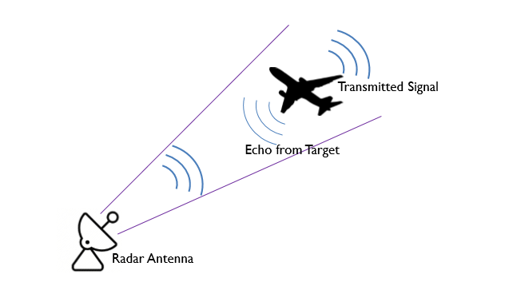

*Basic operating Principle of a Radar*

Initially the radar transmitter, by means of an antenna, radiates energy in space, in the shape of electromagnetic waves. Through space, electromagnetic waves might come across with an object, called target. Depending on the reflectivity of the target, a portion of the energy will be reflected back. The electromagnetic energy hitting the target, is reflected in multiple directions. One of the directions comes to be the same direction of the initially radiated electromagnetic wave. This energy is received by the radar receiver antenna. After an amplification and with the assistance of convenient signal processing, by defining a threshold of the received echo’s amplitude, a decision must be made in whether there is a detection or not in the signal received. After the decision is made, other information about the target can be extracted for further analysis and processing.

### Radar Types

Even though there is not an official classification of the existing radar technologies, the next section will present the main groups and their characteristics:

#### Monostatic/Bistatic Radar

Firstly, there can be distinguished as different radar architectures, the monostatic and bistatic. The difference between them can be found in the design of the transmitter and receiver antennas sides of the system. While the bistatic radars are characterized by a design where the transmitter and receiver antennas are separated spatially, the monostatic architecture is based on the transmission and reception of the signal in the same antenna, without any spatial separation. This is usually performed with a circulator, as shown.

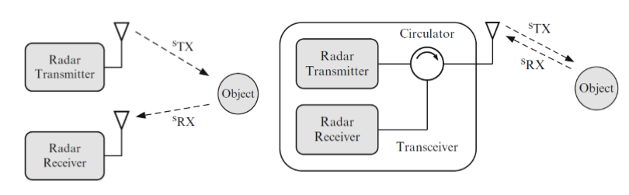

*Schematic portraying Monostatic and Bistatic Radar*

#### Pulse and Continuous Wave Radar

*Pulse radar:* This type of radar radiates multiple and repetitive short and high energy pulses modulated to be able to also obtain the speed information out of the Doppler shifts. The method is method is characterized by the shortness of its transmission pulses, which are usually in the order of the microseconds. After a pulse has been transmitted there is a long period of lack of transmission (T >> Pulse Width). This period is typically named ‘receiving time’, since the length of this silent time interval will be used to interpret the time between the transmitted pulse and reflected one, thus, giving the range unambiguously. In this type of radar is important to consider the control of the timing since the correct calculation of the range depends on the time accuracy calculation.

The pulse is going to be targeted in one particular direction, defined by the directivity of the antenna, at each given moment. The distance from the target can be easily measured in an oscilloscope, evaluating the time between the two observed pulses in the screen (as far as there have not been any other transmitted pulses in the meantime). The traveling of the pulse is a two-way trip, thus, the time measured must be divided by two in order to obtain the one-way time interval that the electromagnetic wave needed to reach the object. This leads us to a simple range equation as:

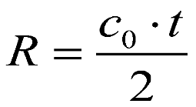

Here,

R = Range of the target, 𝐶o = speed of light in vacuum, t = round trip time

Therefore, once we have obtained the half round trip time t/2, A simple multiplication with speed of light gives us the distance of the object.

Since we will be dealing with Pulse Radar during the course of this report, we will discuss the same in a little more detail.

*Continuous Wave Radars (CW):* This radar technology uses a continuous sine wave at high frequency. It also uses the Doppler frequency shift in order to detect non-standing targets or their relative speed. The spectrum of standing targets would look centered in 𝑓0, if the targets are moving this will be shifted by 𝑓𝑑 (Doppler frequency). This characteristic makes the CW radars highly accurate when estimating the speed. To prevent the transmission disruption of the continuous radiation, two separate antennas need to be used. Thus, all the CW radars are bistatic. There can be distinguished two main types of CW radar systems depending on the modulation they use: Frequency Modulated CW radars (FMCW) and Phase Modulated CW (PMCW) radars.

*FMCW Radars:* This type of modulated radar uses frequency modulation in the source. A VCO (Voltage Controlled Oscillator) generates the signal with up and down chirps with a period of Tp and 50% duty cycle.

*PMCW radars:* This type is also called phase-coded radar. In contradiction with the pulsed radar systems (energy radiated in a short time interval), in this type of modulated radar a method of pulse compression can be used to generate a spread spectrum signal which will span the energy over a long period of time. For this purpose, the phase modulation can be achieved with pseudo-random binary sequences, M-sequences or any other codes that will reduce the peak power of the system.

Since Continuous Wave Radar do not form the focus of this report, we have discussed it in brief.

### Radar Applications

1. ***Air Trafﬁc Control (ATC):*** RADARs are used for safety controlling of the air trafﬁc. It is used in the vicinity of airports for guiding airplanes for proper landing in adverse weather conditions. Usually, high resolution RADAR is employed for this purpose. RADARs are used with ground control approach (GCA) system for safe aircraft landing.
2. ***Aircraft Navigation:*** The weather avoidance RADARs, and ground mapping RADARs are employed in aircrafts to navigate it properly in all the conditions. Radio altimeter and Doppler navigator are also a form of RADAR. These RADARs provide safety to aircraft from potential collision with other aircraft and objects.

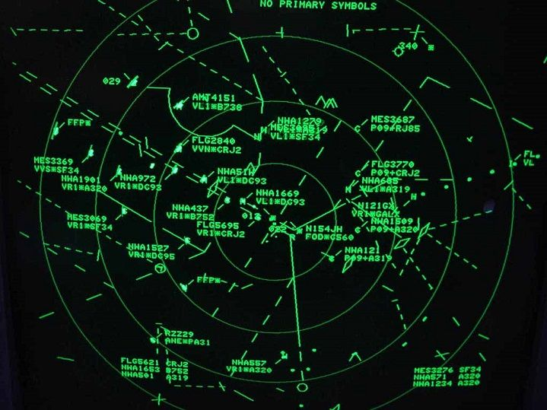

*A typical Airport Radar Surveillance Screen for guiding Air traffic.*

1. ***Ship Navigation and Safety:*** High resolution Shore based RADARs are used for beaconing and as an aid of navigation. During poor visibility due to bad weather conditions, the RADAR provides safe travel by warning potential threats. They are also used to ﬁnd the depth of sea.
2. ***Space:*** RADARs are used for docking and safely landing of spacecrafts. Satellite borne RADARs are also used for remote sensing. Ground based RADARs are used to track and detect the satellites and spacecraft.
3. ***Remote sensing and Environment:*** They are employed in remote sensing for detecting weather (meteorological) conditions of the atmosphere and tracking of planetary conditions.
4. ***Law Enforcements:*** Highway police force widely uses RADARs to measure the vehicle speed for safety regulations.
5. ***Military area:*** As was seen in the historical background RADARs have got wide application in military operations. They are used in air, naval and ground for defence purposes. They are also used for tracking, surveillance, and detection of the target. Weapon control, Fire control and missile guidance is usually employed with various types of RADARs. Long range RADAR is very useful for many purposes. It is generally used to track space objects. Furthermore, it is also used for ballistic missiles.
6. ***Global Ozone Monitoring Experiment (GOME) Applications:*** Atmospheric available ozone and No2 global monitoring have been going on after the invention of GOME Products (July 1996). GOME products can be used for retrieving other trace gases relevant to the ozone chemistry as well as other atmospheric constituents. Furthermore, it can be used for climatic variable clouds, solar index, and aerosols. All these are crucial for assessing climate change.
7. ***Microwave Sounder (MWR) Applications***: To monitor the Antarctic ice cycle ERS-2 microwave sounder is being used. Mapping the radiometric properties of the ice-shelf, gives an important input for the understanding of the dynamics, decay, and growth of ice sheets. This is basic to the understanding of environmental and climatic changes.

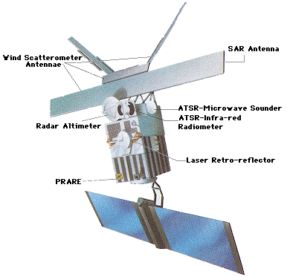

*ERS-2 for various Applications.*

1. ***Wind Scatterometer (WSC) Applications:*** Wind scatterometers are used for accurate measurements of the radar backscatter from the ocean surface when illuminated by a microwave signal with a narrow spectral bandwidth to derive information on ocean surface wind velocity. The amount of backscatter depends on two factors. Dependent on wind stress which results in wind speed at the surface, and wind direction are the two types of factors.
2. ***Land use, Forestry and Agriculture:*** Observing the land surface is being considered as an experimental application for ERS-1 data in the original mission targets. Major potential application area for ERS data are being offered by the ability to monitor crop development and forestry changes independent of weather conditions.
3. ***Other Applications:*** Ground penetrating RADARs are widely used by geologist for studying the position of the earth for Earthquake detection. Scientists use RADAR for better study of movements of animals, birds, and insects. Archaeologists use it for detecting buried artifacts. Many industries and factories use it for safety purposes. During world war-2, Signal corps Radio-270 or Pearl Harbor RADAR was used by US army’s as long-distance RADAR. It played signiﬁcant role in detecting the incoming raid, just before half an hour the attack has commenced and was most useful. RADAR waves blaze an ample path for the rescue teams to search the needy people during the earthquake that detect the heartbeats through the ﬁnder search options of survivors trapped in collapsed and damaged buildings after Nepal Earthquake.

### Radar Frequency Bands

Radars can be operated at a wide range of frequencies. Varying from frequencies as low as few MHz to as high as some hundred GHz, inside, what is called, the millimeter-wave region. A frequency range where radar systems can be found working covers from the 5 MHz up to the 95 GHz bands. The used frequencies in radar vary in a wide frequency range. Thus, it is expected that the technologies associated are different and their use is linked to very different applications with very different capabilities and characteristics. Depending on the application, one frequency of operation is preferred to another.

As a first thought, the high frequency bands show an obvious advantage in applications that need small antennas; due to the small wavelength a more efficient antenna is possible. The short wavelengths permit high gain antennas with a convenient small size. But it is also easier to achieve better accuracy in range and placement of the target due to the wider band used in such frequency’s bands. By the other hand, low frequencies work better for applications with long distances goals since is more feasible to get high power antennas and the electromagnetic

*Atmospheric attenuation of EM waves in accordance with their working frequency.*

waves are less attenuated while propagating in the air. Also, high frequency radars will be more affected by weather conditions (water absorption peak) than a low frequency band radar, in long ranges. Following, an overview of the radar operating bands and applications:

**- HF / VHF (< 300 MHz):** A/B bands: nowadays the technologies that use these frequency bands are called Over the Horizon radars (OTH). The main positive characteristics of this band are the immunity to weather conditions, the long-range capability out to 3500 km (since it is easier to obtain high power transmitters) and the low attenuation they suffer. However, their drawbacks are their low efficiency. Mainly useful for applications over the oceans. The low part of this band takes advantage on the ionosphere reflections to reach longer distances.

**- UHF (300 MHz to 1 GHz) – C band:** These are characterized by low or medium accuracy and resolution, but still are very seldom affected by weather conditions. It is a good frequency band to early detection of aircrafts and Airborne Moving Target Indication (AMTI). It is also good for tracking missiles and satellites. At the upper part of this frequency band there can be found the so-called ‘wind profiler radars’ that are capable of measuring the direction and velocity of the wind. Another application of this frequency band is the Ground Penetrating Radars (GPR), which usually extends further than the UHF band to get better accuracy. These ranges are appropriate to locate big objects under the ground.

**- L band (1 – 2 GHz):** It is commonly used for radars operating in ranges up to 400 km for air surveillance applications. The weather phenomenon starts to be slightly more noticeable in this range, and the more the frequency increases the more the rain effect will be significant. This band is also used for missile surveillance and low orbit satellite tracking.

**- S band (2 – 4 GHz):** used for short range surveillance, up to 120 km. This band is where regional airspace surveillance radars for aviation are located. It has medium accuracy and it can be said that is a band of compromises, relatively long-range coverage with relative accuracy. Another radar application that uses this band is the surveillance aircraft AWACS (Airborne Warning and Control System).

**- C band (4 – 8 GHz):** Used for short range surveillance and long-range tracking with good accuracy. It takes properties from the C and X bands and is highly sensitive to bad weather. Some examples of applications working in this band are the weather radars to locate rains and, surveillance of military battlefield.

**- X band (8 – 12 GHz):** Meant for short range surveillance in good weather conditions. It is well known to be used for military applications, mainly for airborne radars, and it is also common for police speed meters. They are usually very convenient due to the size of the antennas, so they are very popular for applications where weight and mobility are the main factors to take into account.

**- Ku / Ka bands (12 – 40 GHz):** Mainly for short-range tracking. Since the higher the frequency the more is the atmosphere absorption, this band is good for applications where weather conditions are not considered. This band is attractive when it comes to applications that require very little installation space and don’t need long ranges. An application working in this range is the Surface Radar in the major airports.

**- V / W / mm-Wave bands (40 – 100+ GHz):** This range is clearly limited to short or very short ranges, depending on the weather conditions, and mainly work besides smart antennas which are able to point their very thin beams. In this wide band there is particular interest around the 96 GHz zone, since there is a relative minimum of attenuation. The effects and technology of the mm-wave technology are different than those of the microwave radar technology, and both are more limiting in the mm-wave radar technology. The use of this band has lately become more popular because of many advantages. The main one, is the availability of a wide band of frequencies, there is a lot of unused space, so that the radar systems to be developed in this region can have a wide bandwidth which will give higher range resolution and narrower beams with smaller antennas. It is also very well considered for its robustness, for example, for military applications where countermeasures are expected. Nowadays there are big investments in mm wave radar for automotive applications due to its small size and very good values of accuracy and resolution. Usually these automotive systems operate in the range from 73 to 81 GHz.

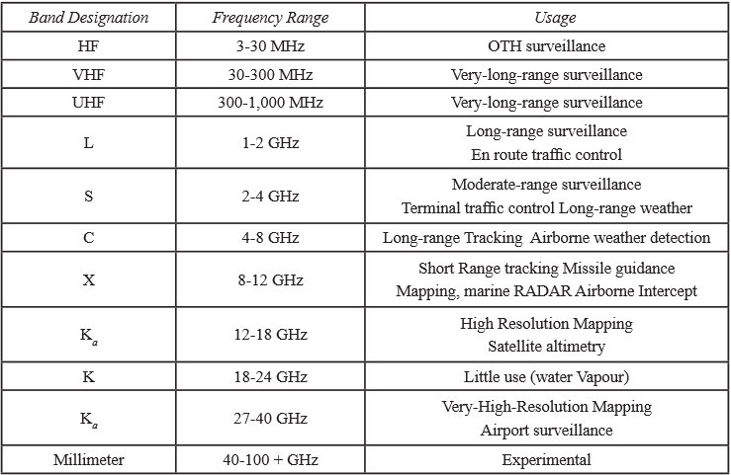

*Radar Frequency bands and specific applications.*

## Objective

In this report we seek to simulate a Pulsed Radar System. In the designing part, we seek to take into consideration various parameters that goes into estimating the range and velocity of a target. Once a successful simulation can be carried out for a simple model, the dependence of various parameters that goes into estimating the true range can then be correlated and studied. The range and velocity estimation are to be done for a single target and a multi target system. The signal processing and visualisation of result is the true aim. The idea is to not just detect a target but to go into understanding the concept of range and velocity gates so as the estimate true range and velocity of the target.

## Software Used

The simulation and performance analysis of our system was carried out by using MATLAB and Simulink software developed by MathWorks. The software provides a very user friendly and interactive user interface. It is important to mention here that Phased Array System Toolbox™ package of the software made our work easy. It provides algorithms and apps for the design, simulation, and analysis of sensor array systems in radar, wireless communication, EW, sonar, and medical imaging applications. We can design phased array systems and analyze their performance under different scenarios using synthetic or acquired data.

The toolbox provided us with already existing models of the blocks that we wanted to use in our system design. Just by toggling with the data in the blocks of the existing models we were able to focus on our main task which was to understand the backend processing of the signal that goes into calculating the range and velocity of the target.

## Report Overview

This section deals with the overview of various sections of this report.

**Chapter 1** proves a basic introduction on Radar system. As we have seen we went into the Radar basics, it’s history, types and various applications.

**Chapter 2** covers the radar range equation in detail. It looks into seeking various parameters that affects radar range. The loses that the wave encounters are also explained in brief. Also, the DB scale estimation of Radar Range equation is also shown.

**Chapter 3** goes into simulating a monostatic pulse radar for a single and multitarget environment. Each block and its functioning is explained in detail. The results that have been obtained have been discussed in brief.

**Chapter 4** investigates velocity estimation using a MATLAB code. It introduces the doppler effect that the shows how the change in frequency i.e. doppler frequency can be used to obtain the radial velocity of the target.

**Chapter 5** concludes our report.

# The Radar Range Equation

Whatever functions the radar seeks to achieve, the performance is inﬂuenced by the strength of the signal coming into the radar receiver from the target of interest and by the strength of the signals that interfere with the target signal. In the special case of receiver thermal noise being the interfering signal, the ratio of target signal to noise power is called the signal-to-noise ratio (SNR); if the interference is from a clutter signal, then the ratio is called signal-to-clutter ratio (SCR). The ratio of the target signal to the total interfering signal is the signal-to-interference ratio (SIR). The equation the radar system designer or analyst uses to compute the SIR is the radar range equation (RRE). A relatively simple formula, or a family of formulas, the RRE predicts the received power of the radar’s radio waves “reﬂected” from a target and the interfering noise power level and, when these are combined, the SNR. In the forthcoming section we will try and establish the same.

## Power density at a distance R

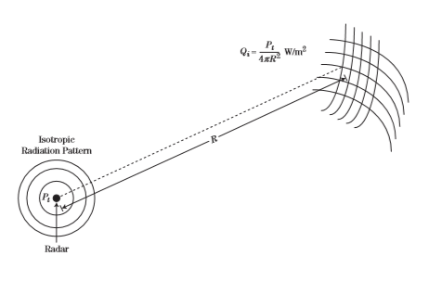

*Power Radiation Of an isotropic Antenna.*

The total peak power (watts) developed by the radar transmitter, , is applied to the antenna system. If the antenna had an isotropic or omnidirectional radiation pattern, the power density (watts per square meter) at a distance R (meters) from the radiating antenna would be the total power divided by the surface area of a sphere of radius R. It is given as:

Essentially all radar systems use an antenna that has a directional beam pattern rather than an isotropic beam pattern. In this case, the power density at the centre of the antenna beam pattern is higher than that from an isotropic antenna, because the transmit power is concentrated onto a smaller area on the surface of the sphere.

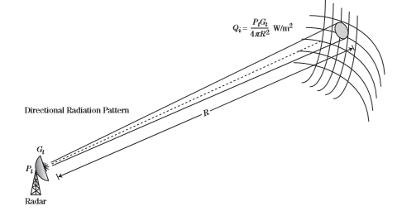

*Power transmission in a narrow beam.*

The ratio between the power density for a lossless directional antenna and a hypothetical isotropic antenna is termed the directivity. The gain, G, of an antenna is the directivity reduced by the losses the signal encounters as it travels from the input port to the point at which it is “launched” into the atmosphere The subscript t is used to denote a transmit antenna, so the transmit antenna gain is . Given , the increased power density due to use of a directional antenna is:

## Recovered Power from a Target

Next, consider a radar “target” at range R, illuminated by the signal from a radiating antenna. The incident transmitted signal is reﬂected in a variety of directions. The power reﬂected by the target back toward the radar, , is expressed as the product of the incident power density and a factor called the radar cross section (RCS) σ of the target. The units for RCS are square meters (m2). The radar cross section of a target is determined by the physical size of the target, the shape of the target, and the materials from which the target is made, particularly the outer surface.2 The expression for the power reﬂected back toward the radar, , from the target is:

The reflected signal propagates back towards radar system over a distance R so that power density back at the radar receiver antenna is given as:

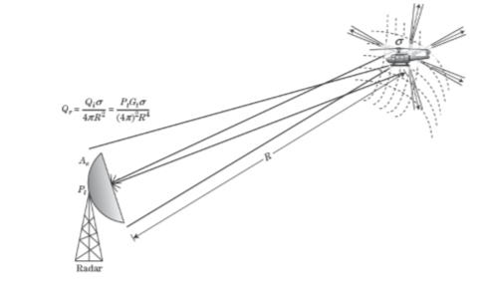

*Power density reflected back at the Radar*

This reflected wave with given power density after travelling distance R is now received by the receiving antenna of effective area . The power received at receiving Antenna can be given as:

It is customary to replace effective area Antenna term with Receive Antenna gain . Also, because of tapering and losses, the effective area of the antenna is somewhat less than physical area A. The relationship between effective area Ae and antenna gain G is given as:

Where, is the antenna efﬁciency. Antenna efﬁciency is a value between 0 and 1; however, it is seldom below 0.5 and seldom above 0.8. Putting this value in , we get:

In this expression,

is the peak transmitted power in watts.

is the gain of the transmit antenna.

is the gain of the receive antenna.

λ is the carrier wavelength in meters.

σ is the mean RCS of the target in square meters.

R is the range from the radar to the target in meters.

## Receiver Thermal Noise

In the ideal case, the received target signal, which usually has a very small amplitude, could be ampliﬁed by some arbitrarily large amount until it could be visible on a display or within the dynamic range of an analogy-to-digital converter (ADC). Unfortunately, there is always an interfering signal described as having a randomly varying amplitude and phase, called noise, which is produced by several sources. Random noise can be found in the environment, mostly due to solar effects.

In addition to antenna noise, thermally agitated random electron motion in the receiver circuits generates a level of random noise with which the target signal must compete. Though there are several sources of noise, the development of the radar range equation in this chapter will assume that the internal noise in the receiver dominates the noise level. This section presents the expected noise power due to the active circuits in the radar receiver. For target detection to occur, the target signal must exceed the noise signal and, depending on the statistical nature of the target, sometimes by a signiﬁcant margin before the target can be detected with a high probability. Thermal noise power is essentially uniformly distributed over all radar frequencies; that is, its power spectral density is constant, or uniform. It is sometimes called “white” noise. Only noise signals with frequencies within the range of frequencies capable of being detected by the radar’s receiver will have any effect on radar performance. The range of frequencies for which the radar is susceptible to noise signals is determined by the receiver bandwidth, B. The thermal noise power adversely affecting radar performance will therefore be proportional to B. The power, , of the thermal noise in the radar receiver is given by:

where k is Boltzmann’s constant (1.38×10−23 watt-sec/K). To is the standard temperature (290 K). Ts is the system noise temperature ( = F). B is the instantaneous receiver bandwidth in Hz. F is the noise ﬁgure of the receiver subsystem (unitless).

The noise ﬁgure, F, is an alternate method to describe the receiver noise to system temperature, Ts. It is important to note that noise ﬁgure is often given in dB; however, it must be converted to linear units for use in equation.

As can be seen, the noise power is linearly proportional to receiver bandwidth. However, the receiver bandwidth cannot be made arbitrarily small to reduce noise power without adversely affecting the target signal.

If the receiver bandwidth is made smaller than the target signal bandwidth, the target power is reduced, and range resolution suffers. If the receiver bandwidth is made larger than the reciprocal of the pulse length, then the signal to noise ratio will suffer. The optimum bandwidth depends on the speciﬁc shape of the receiver ﬁlter characteristics. In practice, the optimum bandwidth is usually on the order of 1.2/τ, but the approximation of 1/τ is very often used.

## Signal to Noise Ratio (SNR)

When the received target signal power, , is divided by the noise power, , the result is called the signal-to-noise ratio (SNR), which is given as:

## Summary of Losses

To this point, the radar equation has been presented in an idealized form; that is, no losses have been assumed. Unfortunately, the received signal power is usually lower than predicted if the analyst ignores the effects of signal loss. Atmospheric absorption, component resistive losses, and nonideal signal processing conditions lead to less than ideal SNR performance. This section summarizes the losses most often encountered in radar systems and presents the effect on SNR. Included are losses due to clear air, rain, component losses, beam scanning, straddling, and several signal processing techniques. It is important to realize that the loss value, if used in the denominator of the RRE as previously suggested, must be a linear (as opposed to dB) value greater than 1. Often, the loss values are speciﬁed in dB notation. It is convenient to sum the losses in dB notation and ﬁnally to convert to the linear value. The following equation provides the total system loss term

=

where

is the system loss.

is the transmit loss.

is the atmospheric loss.

is the receiver loss.

is the signal processing loss.

As a result of incorporating the losses, the RRE becomes

## Solving for other variables

### Range as dependent variable

An important analysis is to determine the detection range, R, at which a given target RCS can be detected with a given SNR.

We can now clearly relate various factors that we can correlate to calculate maximum detectable range. It is imperative to not here that some losses have been neglected in reaching the above equation. It is done so because in the simulation that we will seek to do we assume that those losses are not present.

### Solving for minimum detectable RCS

Another important analysis is to determine the minimum detectable radar cross section,. This calculation is based on assuming that there is a minimum SNR, , required for reliable detection.

As

Clearly, the Radar Power equation could be solved for any of the variables of interest. However, these provided forms are most used.

## Decibel Form of Radar Range Equation

Many radar systems engineers use the previously presented algebraic form of the radar equation, which is given in linear space. That is, the equation consists of a set off values that describe the radar parameters in watts, seconds, or meters, and the values in the numerator are multiplied and then divided by the product of the values in the denominator. Other radar systems engineers prefer to convert each term to the dB value and to add the numerator terms and subtract the denominator terms, resulting in SNR being expressed directly in dB. The use of this form of the radar equation is based strictly on the preference of the analyst. Many of the terms in the SNR equation are naturally determined in dB notation, and many are determined in linear space, so in either case some of the terms must be converted from one space to the other. The terms that normally appear in dB notation are antenna gains, RCS, noise ﬁgure, and system losses. It remains to convert the remaining values to dB equivalents and then to proceed with the summations. The Radar Range Equation in dB form can be given as:

In the above presentation in the constant values (e.g., π, ) have been converted to the dB equivalent. For instance, ≈ 1,984, and10log10(1,984) ≈ 33dB.Since this term is in the denominator, it results in –33 dB. The (−204) [dBW/Hz] term results from the product of k and To. To use orders of magnitude that are more appropriate for signal power and bandwidth in the radar receiver, this is equivalent to –114 dBm/MHz. Remembering this value makes it easy to modify the result for other noise temperatures, the noise ﬁgure, and the bandwidth in MHz. In addition to the simplicity associated with adding and subtracting, the dB form lends itself more readily to tabulation and spreadsheet analysis.

The Radar range equation forms the underlying concept for Radar performance assessment. Hence, it has been discussed in some detail in this chapter.

# Pulsed Radar Processing and Range Estimation

In this chapter, we will try and simulate some Radar models and arrive at certain results and understand the signal processing behind the range estimation for single and multitarget system.

Along the way, we will keep understanding of how we have reached to the results that we have got.

## Pulse Radar

The most common type of radar signal consists of a repetitive train of short-duration pulses. The figure shows a simple representation of a sine-wave pulse that might be generated by the transmitter of a medium-range radar designed for aircraft [detection](https://www.britannica.com/technology/detection). The sine [wave](https://www.britannica.com/science/wave-physics) in the figure represents the variation with time of the output voltage of the transmitter. The numbers given in parentheses in the figure are meant only to be illustrative and are not necessarily those of any particular radar. They are, however, similar to what might be expected for a ground-based radar system with a range of about 50 to 60 nautical miles (90 to 110 km), such as the kind used for [air traffic control](https://www.britannica.com/technology/air-traffic-control) at airports. The pulse width is given in the figure as 1 microsecond (10−6 second). It should be noted that the pulse is shown as containing only a few cycles of the sine wave; however, in a radar system having the values indicated, there would be 1,000 cycles within the pulse. In the figure the time between successive pulses is given as 1 millisecond (10−3 second), which corresponds to a pulse repetition frequency of 1 kilohertz (kHz). The power of the pulse, called the peak power, is taken here to be 1 megawatt. Since a pulse radar does not radiate continually, the average power is much less than the peak power. In this example, the average power is 1 kilowatt. The average power, rather than the peak power, is the measure of the capability of a radar system. Radars have average powers from a few milliwatts to as much as one or more megawatts, depending on the application.

A weak echo signal from a target might be as low as 1 picowatt (10−12 watt). In short, the power levels in a radar system can be very large (at the transmitter) and very small (at the receiver).

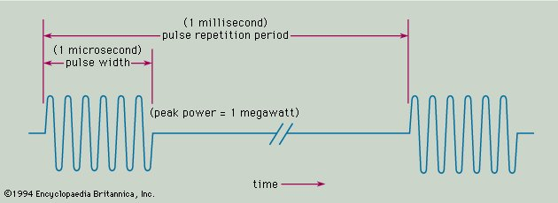

*A typical Pulse Radar Pulse transmitted towards a Target*

## Basic Radar System

*A Typical Radar System*

The figure shows the basic parts of a typical radar system. The transmitter generates the high-power signal that is radiated by the [antenna](https://www.britannica.com/technology/antenna-electronics). In a sense, an antenna acts as a “transducer” to couple electromagnetic energy from the [transmission](https://www.britannica.com/technology/transmission-engineering) line to radiation in space, and vice versa. The duplexer permits alternate transmission and reception with the same antenna; in effect, it is a fast-acting switch that protects the sensitive [receiver](https://www.britannica.com/technology/receiver) from the high power of the transmitter.

The receiver selects and amplifies radar echoes so that they can be displayed on a television-like screen for the human operator or be processed by a computer. The signal processor separates the signals reflected by possible targets from unwanted clutter. Then, on the basis of the echo’s exceeding a predetermined value, a human operator or a [digital computer](https://www.britannica.com/technology/digital-computer) circuit decides whether a target is present.

Once it has been decided that a target is present and its location (in range and angle) has been determined, the track of the target can be obtained by measuring the target location at different times. During the early days of radar, target tracking was performed by an operator marking the location of the target “blip” on the face of a [cathode-ray tube](https://www.britannica.com/technology/cathode-ray-tube) (CRT) display with a [grease](https://www.britannica.com/technology/grease-lubricant) pencil. Manual tracking has been largely replaced by automatic electronic tracking, which can process hundreds or even thousands of target tracks simultaneously.

The system control optimizes various [parameters](https://www.merriam-webster.com/dictionary/parameters) on the basis of environmental conditions and provides the timing and reference signals needed to permit the various parts of the radar to operate effectively as an [integrated](https://www.merriam-webster.com/dictionary/integrated) system.

## Some important terms

The pulse radar sends a pulse when it is in “on” stage and then switches “off” for a specific duration. In the switched off stage it waits for the echo to arrive from which it can gather specific information. This leads us to understanding the wave form of a pulse Radar.

### Pulse Width (PW)

The duration for which the radar is in “on” stage is known as pulse width. It is important parameter in range resolution estimate of the radar which we will see in next section.

### Pulse Bandwidth (PBW)

The reciprocal of pulse width gives the bandwidth of the pulse.

### Pulse Repetition Interval (PRI)

The total duration of “on” and “off” stage of the Radar for one single pulse is known as Pulse Repetition Interval.

### Pulse Repetition Frequency (PRF)

The reciprocal of PRT is PRF. This is the frequency by which the pulse repeats itself. It is an important parameter for maximum *unambiguous* range that can be detected by a Radar as will be seen ahead.

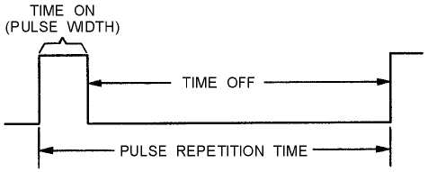

*Figure explaining the waveform of a Pulse Radar*

## Maximum Unambiguous Range

The range of the target, as was seen in chapter 2 by using Radar Range equation depends upon the factors as was established by it. But, to say with complete surety about the location of a target, the pulse properties are of great consideration. This introduces us to the concept of maximum *unambiguous* Range.

Maximum *unambiguous* Range () is the longest range to which the transmitted pulse can travel out to and back again between two consecutive transmitted pulses. In other words, is the maximum distance radar energy can travel round trip between pulses and still produce reliable information.

Suppose that a pulse is emitted at time instant t=0 and an echo is received at a certain time instant t=t’. It can so happen that we receive the echo at t’ < PRT, t’ = PRT, t’ > PRT. If we receive the echo within the PRT we can clearly mention that the echo was received from the first pulse that we had sent. But, if t’ > PRT, we may not clearly say whether the echo is from the first or the second pulse thus introducing an ambiguity. Thus, the maximum *unambiguous* range is obtained by the following formula by using simple speed distance relation:

Where,

= Velocity of EM Wave in vacuum.

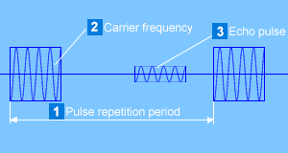

*Echo to be received before the next pulse is sent to avoid Range ambiguity.*

## Range Resolution

Range resolution defines the ability of a radar that allow it to distinguish between two objects which are very close in range. The pulse width defines this ability of the radar. If we have two targets very close to each other such that they are separated in time less than the pulse width of the transmitted pulse, the radar may not be able to resolve them and we would see the two targets as one.

Hence, the range resolution of a Radar can be given as:

*Lesser the Pulse width greater is the range resolution of a target.*

## Probability of Detection and False Alarm

The process of detecting a target begins with comparing a radar measurement with a threshold. Measurements exceeding the threshold are associated with returns from a target, and measurements below the threshold are associated with thermal noise or other interference sources including intentional jamming and background returns from terrain and bodies of water. The detector threshold is selected to achieve the highest possible probability of detection for a given signal-to-noise ratio (SNR) and probability of false alarm. A false alarm occurs when, in the absence of a target, a source of interference produces a measured value that exceeds the detection threshold.

A radar system is designed to achieve and maintain a speciﬁed probability of false alarm. False alarms drain radar resources by appearing as valid target detections requiring subsequent radar actions and thus degrade system performance. If the statistics of the interference are known a priori, a threshold may be selected to achieve a speciﬁc probability of false alarm. In many cases, the form of the probability density function (PDF) associated with the interference is known, but the parameters of the distribution are either unknown or change temporally or spatially. Constant false alarm rate (CFAR) detectors are designed to track changes in the interference and to adjust the detection threshold to maintain a constant probability of false alarm.

The probability of detection can be given as below:

The probability that defines the probability that detection will be greater than the threshold when it is not is the probability of false alarm. It can be defined as:

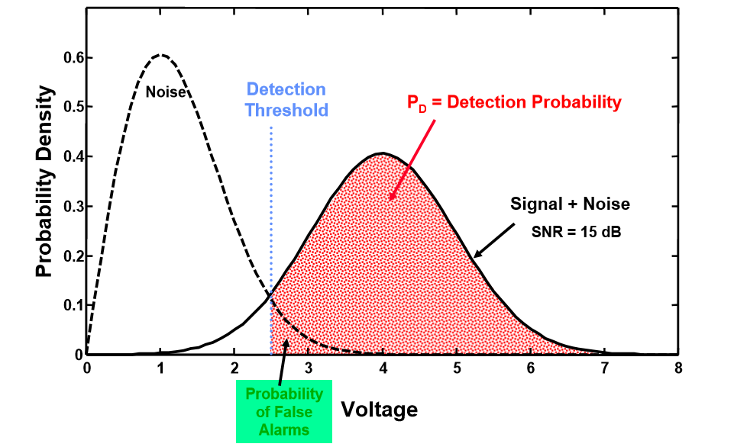

*Probability density function of the noise and received signal*

The threshold should be set higher to reduce the probability of false alarm. It may require us to achieve greater signal to noise ratio and is one of the important parameters in analysing radar’s performance. We will not go in much detail in assessing the statistical point of view these terms but will use them to arrive at our results.

## Single Target simulation

In this section we seek to design a monostatic pulse radar model wherein we will try and estimate the range of a single target with requirements as under.

Maximum *unambiguous* Range = 6km = 6000 m

Range Resolution ( = 50 m

Given that Radar target cross section = 1 square metre

Probability of False Alarm Pfa = 1e-9

Probability of detection Pd = 0.9

### The initial simulating models

The simulation model designed by us is given as under:

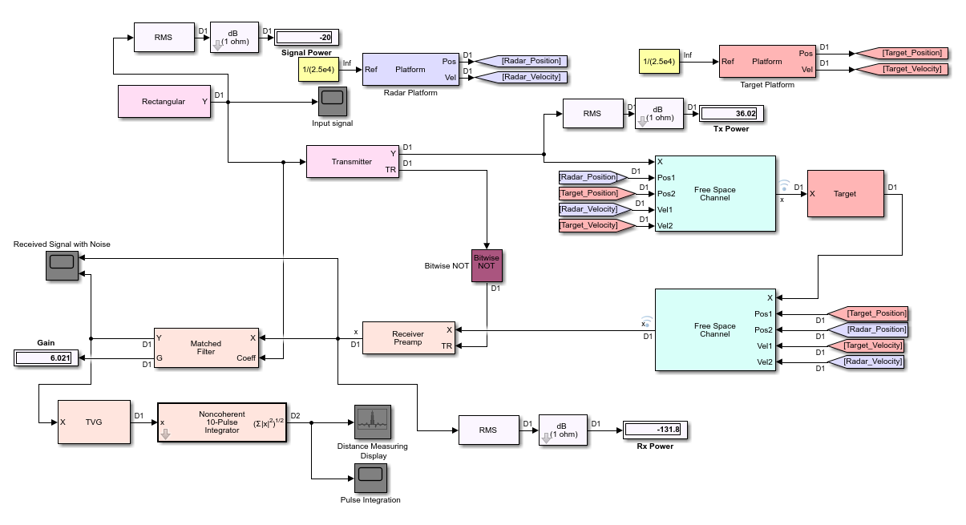

*Initial simulation model*

Hereafter, we will investigate each block of our simulation system and try and arrive at the result we seek to achieve.

### Waveform generation

We choose a rectangular waveform in this simulation. With the above requirements our waveform (rectangular) needs to have the following characteristics:

= sec

=2.5e+4 Hz

The sampling of pulse into equal intervals is done to estimate the true range by evaluating the echo falling in a sample. The sampling rate (is an integer multiple of the PRF. We have chosen This will provide us 400 samples in one PRI during our signal processing to estimate the range that we seek to detect. The waveform in Simulink is generated using the rectangular block of our simulation model. It is an inbuilt block in Simulink belonging to Phased Array System Toolbox. After putting in the above specifications, the waveform that we generated looked as under:

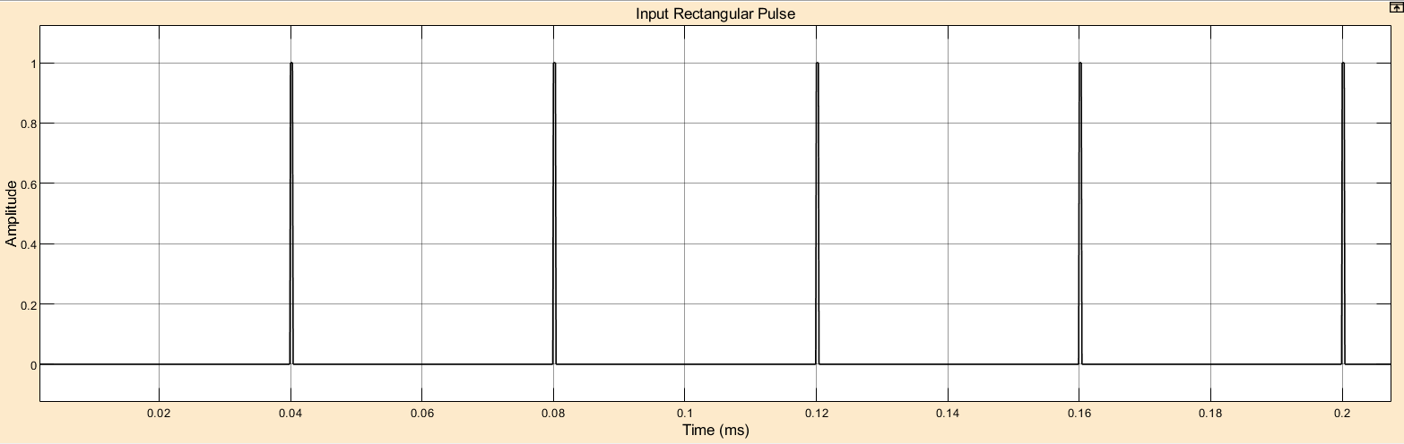

*Input Waveform*

### Transmitter

The inbuilt transmitter block transmits and amplify the signal. Transmitter can either maintain coherence between pulses or insert phase noise. The most critical parameter of a transmitter is the peak transmit power. The required peak power is related to many factors including the maximum unambiguous range, the required SNR at the receiver, and the pulse width of the waveform. Among these factors, the required SNR at the receiver is determined by the design goal of Pd and Pfa, as well as the detection scheme implemented at the receiver. To calculate the required Power for target detection at the required range, we can directly use the Radar Equation calculator app provided by MATLAB. The carrier frequency that we used for our simulation is 5GHZ. This corresponds to a wavelength of 0.06 meters. Using these parameters, we calculated the Peak transmit Power by Radar Equation calculator app as shown. The app takes into consideration the values of Pfa and Pd and by itself calculates the SNR. We will be using the noncoherent pulse integration of 10 pulses in this simulation which is also taken into consideration while arriving at the Peak Transmit Power. The peak Transmit Power that we need to send for our specifications turns out to be 3.529kW. Since we are only concerned about one target detection in this simulation, we are directly sending the signal to the target and are not using an antenna. We are using a monostatic model, so we have used a platform that defines radar position and velocity.

### Propagation channel

The Free Space Channel block propagates the signal from one point to another in space. The block models propagation time, free space propagation loss and Doppler shift. The block assumes that the propagation speed is much greater than the target.

When propagating a signal in free-space to an object and back, you have the choice of either using a single block to compute a two-way free space propagation delay or two blocks to perform one-way propagation delays in each direction. We have used one-way propagation each for transmission and reception of data.

### Target

The Radar Target block models a radar target that reflects the signal according to the specified radar cross section (RCS). Since we are using 1 square meter radar cross section, the same is specified in this block. The target position is specified using a Target platform and specifying the limits that we want to test. The target positions and velocity are given by its platform block.

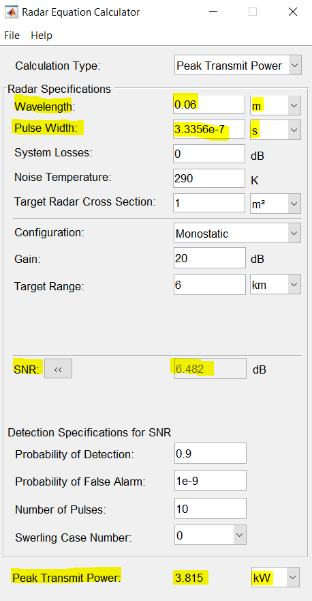

*Radar Equation calculator for Peak Transmit Power*

### Receiver Preamplifier

The Receiver Preamp block implements a receiver preamplifier that amplifies an input signal and adds thermal noise. We assume that the only noise present at the receiver is the thermal noise, so there is no clutter involved in this simulation. The power of the thermal noise is related to the receiver bandwidth. The receiver's noise bandwidth is set to be the same as the bandwidth of the waveform. This is often the case in real systems. We also assume that the receiver has a 20 dB gain and a 1 dB noise figure.

Note that because we are modeling a monostatic radar, the receiver cannot be turned on until the transmitter is off. Therefore, we set the EnableInputPort property to true so that a synchronization signal can be passed from the transmitter to the receiver. This is done by using a Bitwise NOT block in our simulation.

### Detection Threshold

The detector compares the signal power to a given threshold. In radar applications, the threshold is often chosen so that the Pfa is below a certain level. In this case, we assume the noise is white Gaussian and the detection is noncoherent. We will in steps see how we arrive at a detection threshold. We have used a MATLAB code for this. The noise power is calculated by the following:

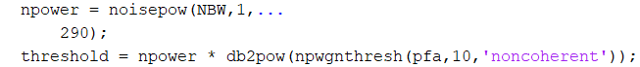

NBW is noise bandwidth which we assumed to be equal to Pulse bandwidth (1/PW). The noisepow() function of matlab calculates the noise power of our system. 1 here is Noise Figure and 290 is the atmospheric temperature. The threshold is calculated by multiplying noise power with SNR threshold as npwgnthresh() calculates the SNR threshold in decibels for detecting a deterministic signal in white Gaussian noise. We have also considered non coherent integration of 10 pulses.

### Matched Filter

The matched filter offers a processing gain which improves the detection threshold. It convolves the received signal with a local, time-reversed, and conjugated copy of transmitted waveform. Therefore, we must specify the transmitted waveform when creating our matched filter. The received pulses are first passed through a matched filter to improve the SNR before doing pulse integration, threshold detection, etc.

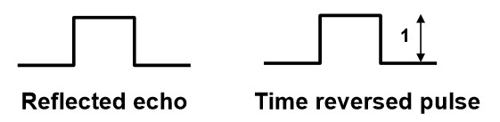

*Reflected Echo and Time Reversed Pulse*

Convolution process involves moving digitized pulses by each other, in steps and when data overlaps, multiply samples and sum them up. In the following explanation we have shown the convolution of a pulse made of three samples.

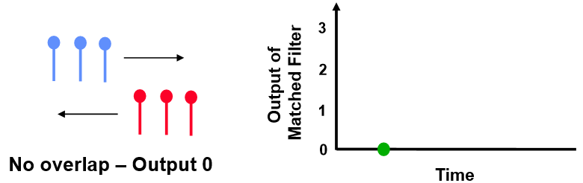

*On no overlapping during convolution*

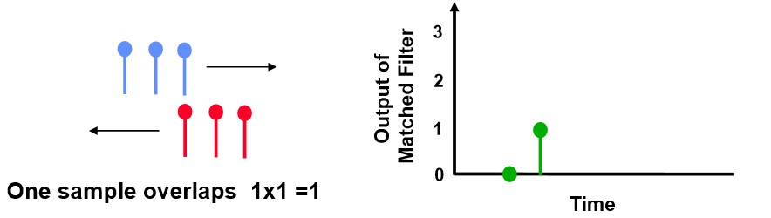

*On convolution when one sample overlap*

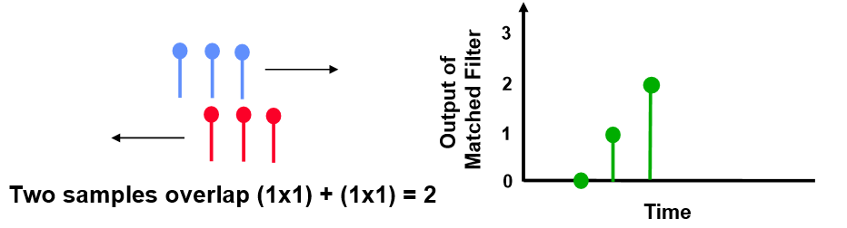

*On convolution when two samples overlap*

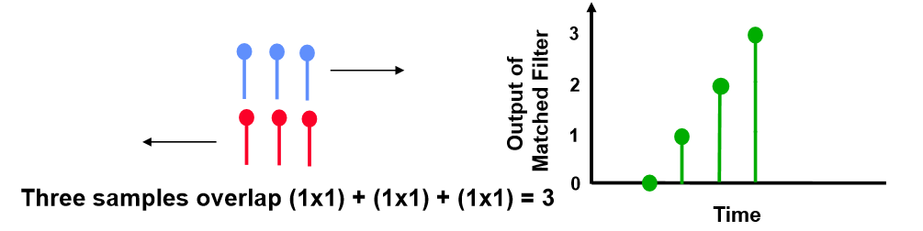

*On convolution when three samples overlap*

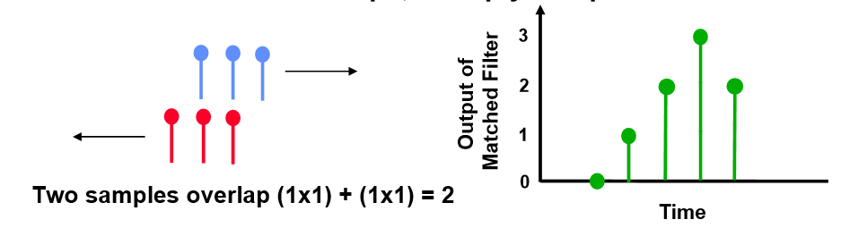*On convolution when, again, two samples overlap*

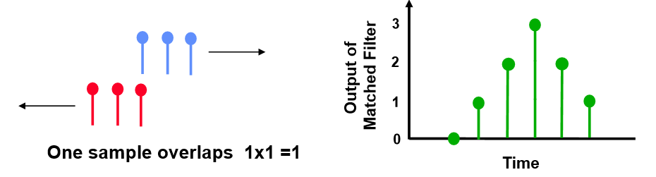

*On convolution when, again, one sample overlaps*

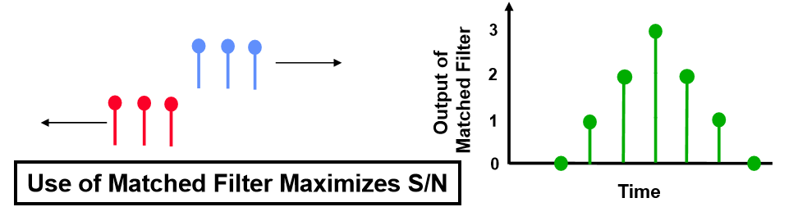

*On convolution when, again, no sample overlaps*

This is how signal to noise ratio improvement is achieved by use of matched filter. The matched filter block does this for us in Simulink. We need to provide the input signal pulse as an input along with the received echo. The matched filter draws its coefficients from the input signal that we have given to it as input and hence improves the SNR.

The threshold is then increased by the matched filter processing gain.

The new threshold is calculated as:



6.021 is the SNR gain output from matched filter. We have taken the square root of the threshold power value because we will define it in terms of amplitude. The output of threshold that we obtained from the above calculation is as under:

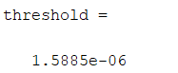

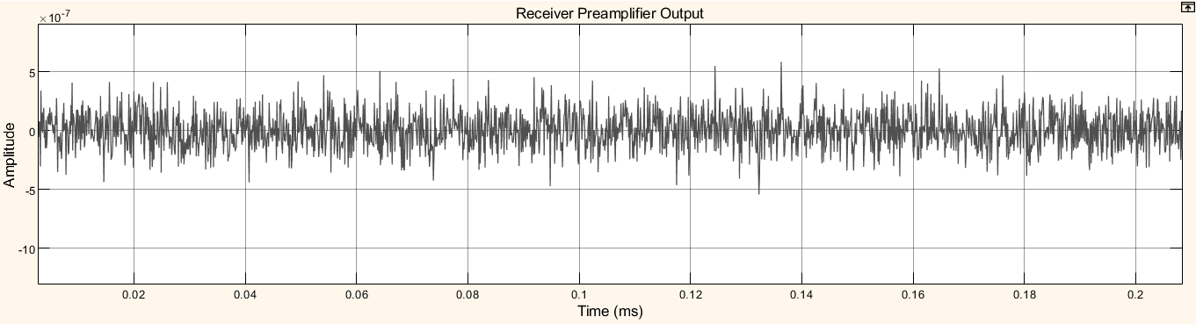

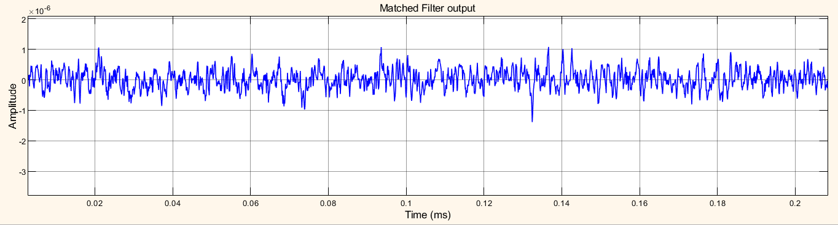

*Improved SNR in Matched Filter Output over Receiver Preamplifier output*

### Time Varying Gain (TVG)

After the matched filter stage, the SNR is improved. However, because the received signal power is dependent on the range, the return of a close target is still much stronger than the return of a target farther away. Therefore, the noise from a close-range bin also has a significant chance of surpassing the threshold and shadowing a target farther away. To ensure the threshold is fair to all the targets within the detectable range, we can use a time varying gain to compensate for the range dependent loss in the received echo.

To compensate for the range dependent loss, we first calculate the range gates corresponding to each signal sample and then calculate the free space path loss corresponding to each range gate. Once that information is obtained, we apply a time varying gain to the received pulse so that the returns are as if from the same reference range (the maximum detectable range).

#### Range Gates

The equal spacing of the Maximum *unambiguous* Range into a number as are the number of samples present in one Pulse Repetition Interval (PRI) is what forms Range Gates. As in our case we saw that there are 400 samples in one PRI. Since our Maximum *unambiguous* Range requirement is 6000 meters, we can say that there are 400 range gates in 6000 meters each separated by 6000/400 = 15 meters.

Range gates are derived from Fast time grids which are nothing but equally spaced PRI. Each time slot is equal to PRI divided by number of samples in one PRI. In our case it is equal to PRI/400 = 1e-7.

Slow time grids are equally spaced time slot where each time slot corresponds to one PRI. The number of slow time grids is equal to number of pulses that we want to collect in our *data matrix* for our further calculations.  *Data Matrix* is nothing but an array of slow and fast time grids.

It is to be noted here that each slow time grid collects the pulse and each fast time grid collects the intensity of the reflected beam of a particular sample. It will not be wrong to say that each fast time grid corresponds to a specific sample in the PRI for every echo that is received. As an example, the 300th fast time grid will record the intensity of the 300th sample of the pulse each time. It is another thing that the sample may or may not contain the echo from a target.

Given below is an example of two targets, one staying in the fast time grid (orange) and one moving in different fast time grids (green).

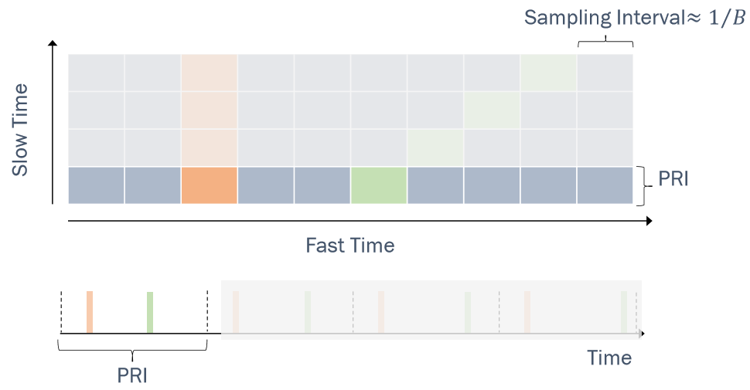

*Targets updated in data matrix for first pulse.*

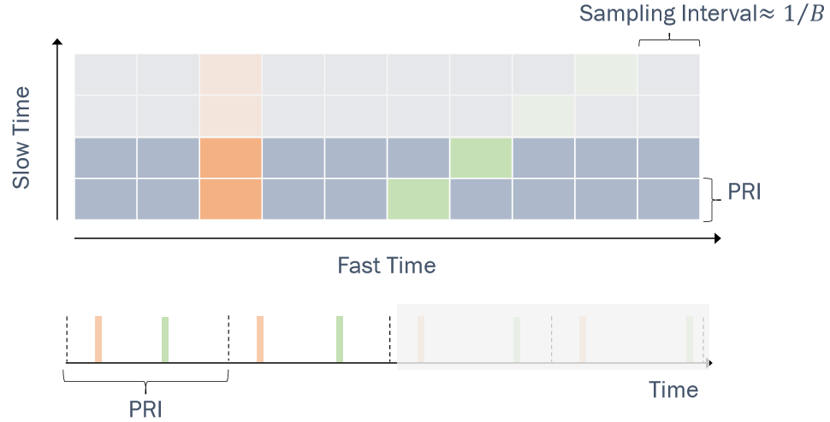

*Targets updated in data matrix for second pulse.*

It is to be mentioned here that B in the figure stand for bandwidth of the pulse which we know as the reciprocal of pulse width. The sampling frequency is usually an integral multiple of the Pulse Bandwidth

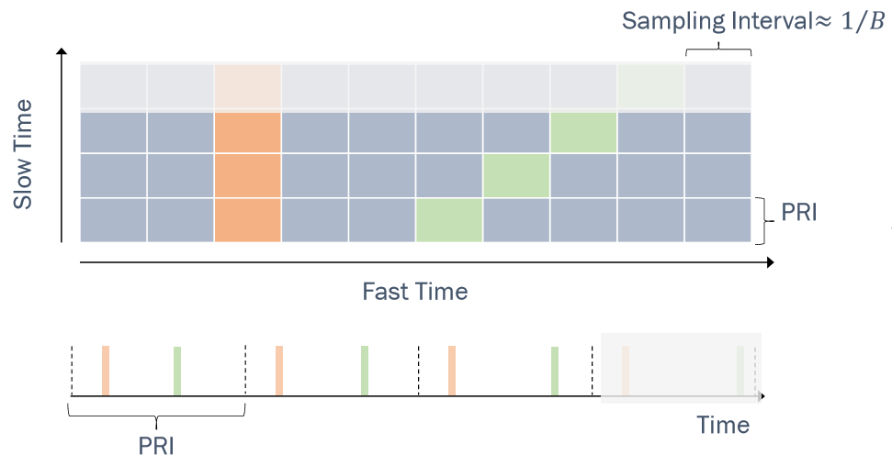

*Targets updated in data matrix for third pulse.*

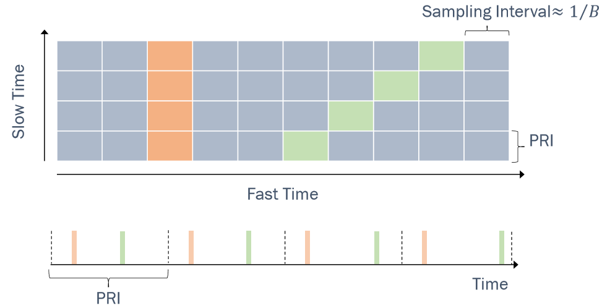

*Targets updated in data matrix for forth pulse.*

This concept is introduced in this section because the time varying gain block use the range gates to introduce gain for various ranges so as to compensate for propagation losses. The TVG block requires us to provide the reference loss which is the free space path loss due to the maximum range that the radar works for. TVG also needs us to provide it with a column of free space path losses due to various range gates. This is accomplished by using the fspl(R, Lambda) function of MATLAB which directly gives us the free space path losses which are then fed to the TVG block. The free space path loss for maximum range is as under. R for us is 6000 meters and lambda i.e. wavelength is 0.06 meters.

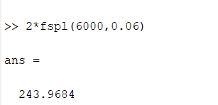

The loss is multiplied by 2 for round trip consideration.

The column path losses for TVG is obtained as under.

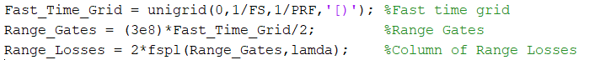

The range loss column is now fed to the TVG for its processing. The improved output for targets at farther ranges is obtained as:

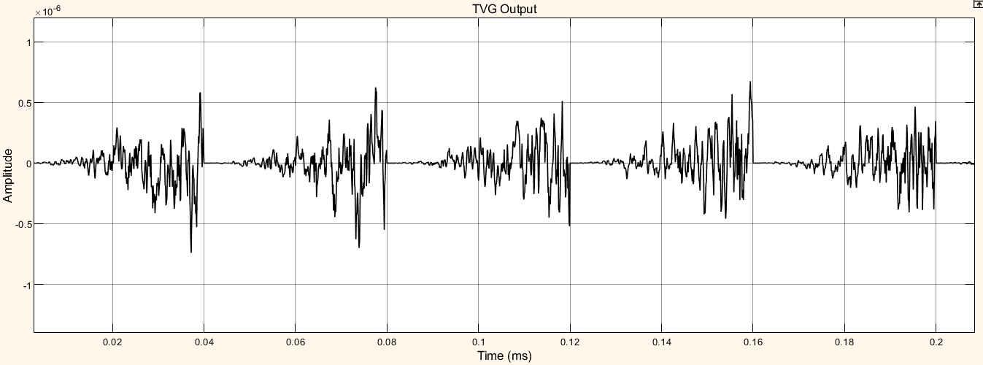

*Gain introduced to compensate for path losses at greater ranges.*

The time varying gain operation results in a ramp in the noise floor. However, the target return is now range independent. A constant threshold can now be used for detection across the entire detectable range.

Received echo may not surpass the threshold value. Therefore, we need to perform pulse integration to ensure the power of returned echoes from the targets can surpass the threshold while leaving the noise floor below the bar. This is expected since it is the pulse integration which allows us to use the lower power pulse train.

### Non-Coherent Pulse integration

It common to use noncoherent integration to improve the SNR. Noncoherent integration discards the phase of the individual echo samples, averaging only the amplitude information. It is easier to perform noncoherent integration. In fact, displaying the signal onto a persistent display whose brightness is proportional to signal amplitude will provide noncoherent integration. Even if the display is not persistent, the operator’s “eye memory” will provide some noncoherent integration. The SNR improvement can be given as:

np ·SNR ≤ SNRnc(np)

Here np = Number of pulses integrated. The improved output obtained after Pulse integration is shown as under.

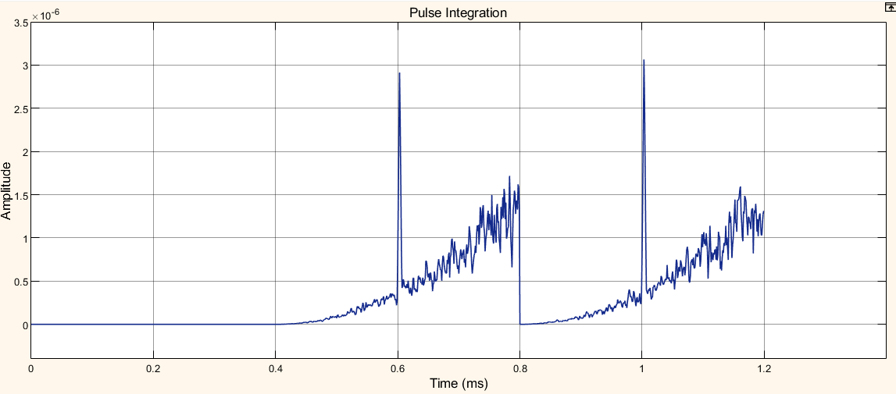

*Considerably improved SNR after Pulse integration*

### Range Estimation

Finally, the Array plot block of Simulink is used to display the detected distance. Since our pulse had 400 samples, the column of these samples is fed to the Array plot. The array plot displays the intensity of these samples with equal spacing. Since the 400 equally spaced margins on the x-axis represent 6000 meters, A sample increment of 15 is given to the Array Plot block.

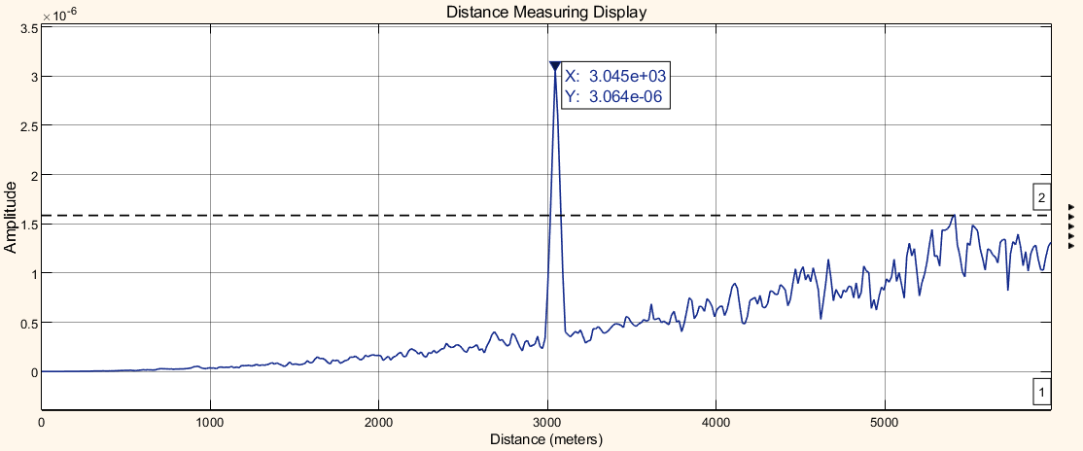

*Range Estimation*

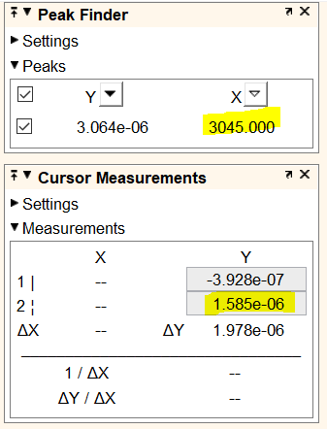

*Peak corresponding to range and defined threshold*

A range of 3045 meters is successfully measured with little error. The received echo is well above threshold value of 1.585e-6. A little noise may also be detected above threshold in some simulations but that would be only approximately above 5800 meters which is quite near to our maximum *unambiguous* Range of 6000 meters. Noise level reaches above threshold near maximum *unambiguous* Range of 6000 meters in very few simulations.

## Multi Target Detections

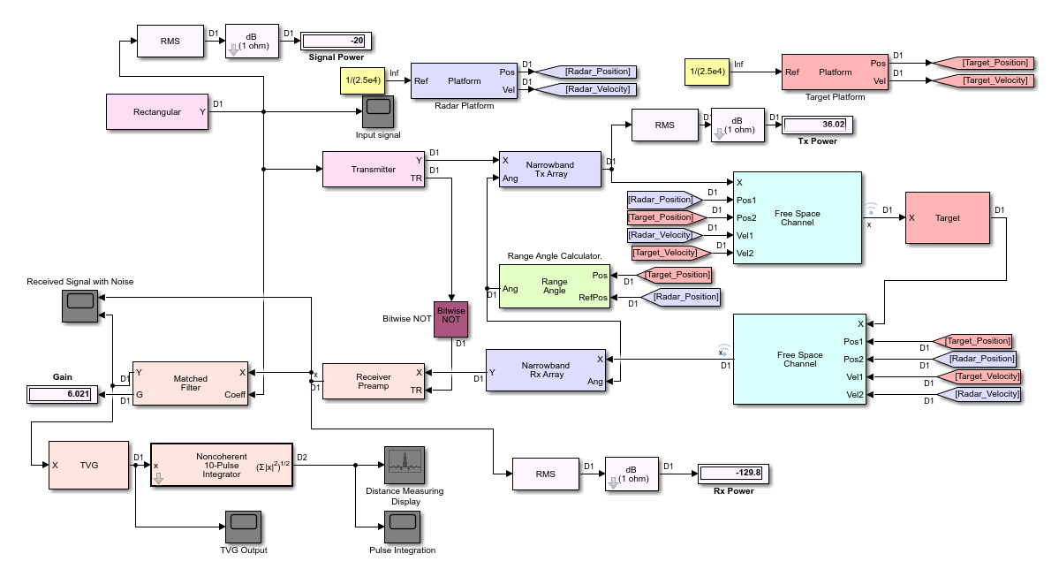

*Schematic for multi target detection*

The parameters that we set to achieve in the previous discussion remains same here as well. We will be able to see a few more characteristics in some detail here.

The explanation and working of most of the schematic remains the same as was in the previous section. The blocks added to the previous example are:

**Narrowband Tx Array** models an antenna array for transmitting narrowband signals. The antenna array is configured using the "Sensor Array" tab of the block's dialog panel.

We are using the most basic antenna i.e. single element Isotropic antenna. We can also analyse the directivity pattern of the type of antenna element by clicking on “Analyze” tab of block’s dialog panel. The same is done in the following picture for an isotropic antenna with single element. The directivity is constant in all the directions.

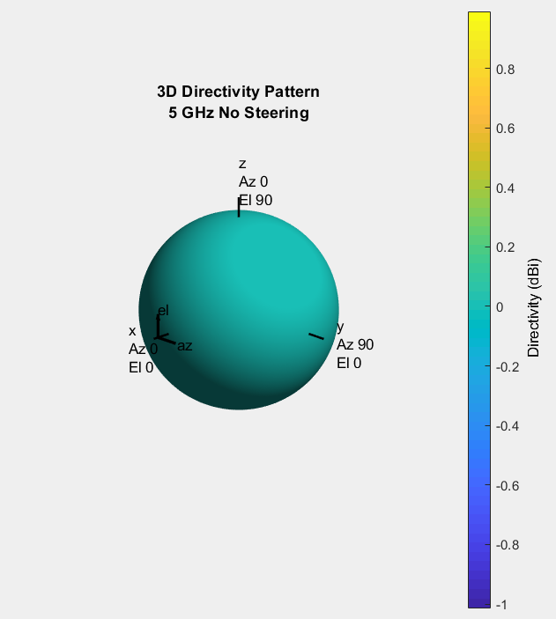

*Analysing the directivity pattern*

The **Range Angle** block calculates the ranges and/or the azimuth and elevation angles of several positions with respect to a reference position (Radar position) and with respect to a reference axes orientation. The reference position and reference axes can be specified in the block dialog or using input ports. This information is fed to the Narrowband Tx and Rx arrays.

Narrowband Rx Array, like the Tx Array models an antenna array for receiving narrowband signals. The received signals are passed onto the Receiver preamplifier for further processing, which remains the same as was in the previous section.

The various output waveforms are shown as under:

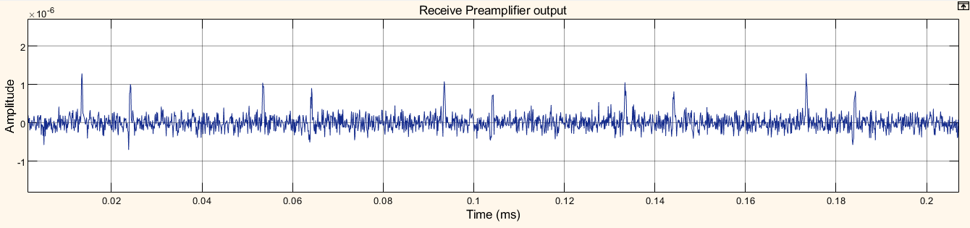 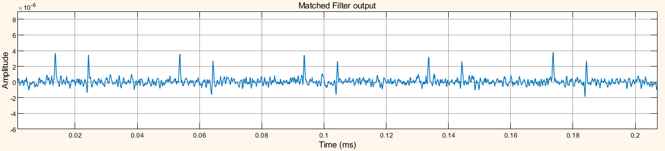

*Receive preamplifier and Matched filter outputs for multitarget*

The increase in the number of peaks shows presence of more than one target.

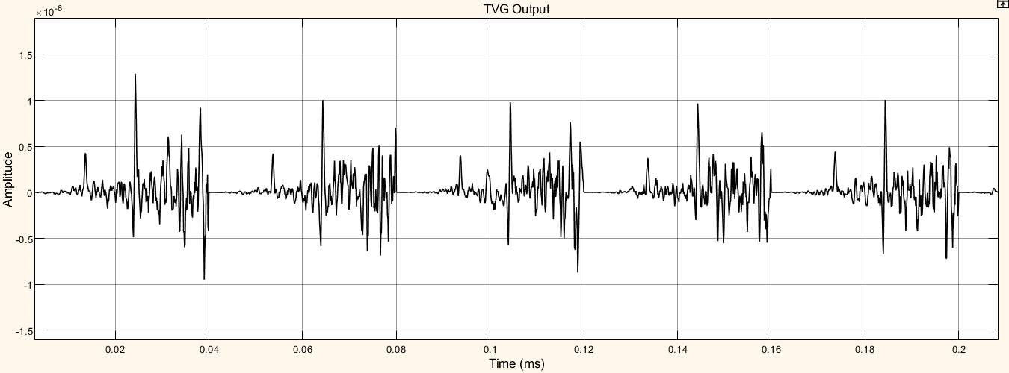

*More prominent peaks in TVG output for multitarget*

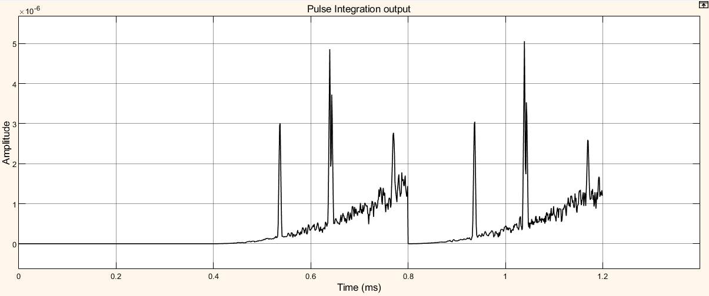*Pulse integration output for multitarget*

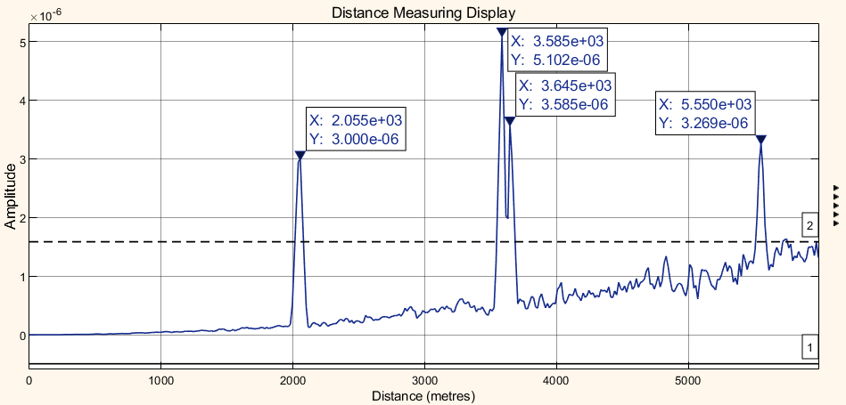

*Multitarget Detection Output*

Four targets have been successfully detected above the threshold value of 1.585e-6. We can clearly note a range resolution of up to 60 meters have been obtained by looking at the targets detected at 3585 meters and 3645 meters. The threshold was set at the same level as was done for single target detection.

Whatever we wanted to address and achieve in range determination was achieved in this chapter. In the next chapter we will device a quite simple model by which we can detect the velocity of a target.

# Velocity Estimation

Till now, we were dealing with stationary objects. We will try and analyse a simple model of velocity estimation using the MATLAB code in this section.

## Doppler Effect

If the target is not stationary, then there will be a change in the frequency of the signal that is transmitted from the Radar and that is received by the Radar. This effect is known as the Doppler effect.

According to the Doppler effect, we will get the following two possible cases −

* The frequency of the received signal will increase when the target moves towards the direction of the Radar.
* The frequency of the received signal will decrease when the target moves away from the Radar.

Now, let us derive the formula for Doppler frequency.

## Derivation of Doppler Frequency

If λ is one wavelength, then the number of wave lengths N that are present in a two-way communication path between the Radar and target will be equal to 2R/λ. We know that one wavelength λ corresponds to an angular excursion of 2π radians. So, the *total angle of excursion* made by the electromagnetic wave during the two-way communication path between the Radar and target will be equal to 4πR/λ radians. Following is the mathematical formula for *angular frequency*, ω –



Following equation shows the mathematical relationship between the angular frequency ω and phase angle ϕ –

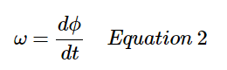

Equate the right-hand side terms of above equations since the left-hand side terms of those two equations are same.

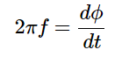

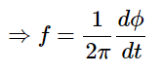

Substitute, f=fd and ϕ=4πR/λ

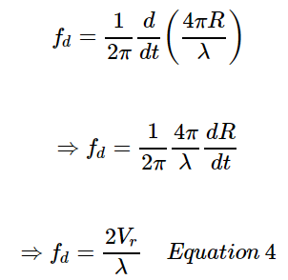

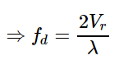

Where,

fd is the Doppler frequency

Vr is the relative velocity

We can find the value of Doppler frequency fd by substituting the values of Vr and λ

Substitute, λ=C/f

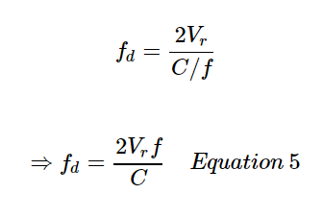

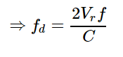

Where,

f is the frequency of transmitted signal

C is the speed of light

We can find the value of Doppler frequency, fd by substituting the values of Vr,f and C.

Note that above are shown two formulae of Doppler frequency, fd. We can use either for finding Doppler frequency, fd based on the given data.

## Velocity estimation using MATLAB Code

We seek to design a model that will estimate the velocity of a single target. The designing of various blocks involved is established first. It is in no way different than the Simulink blocks that we had used earlier. We are just representing them in form of code now. It is done as under.

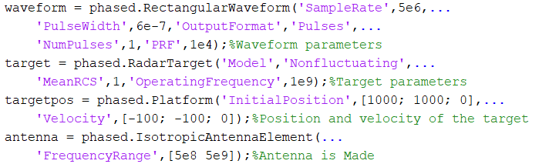

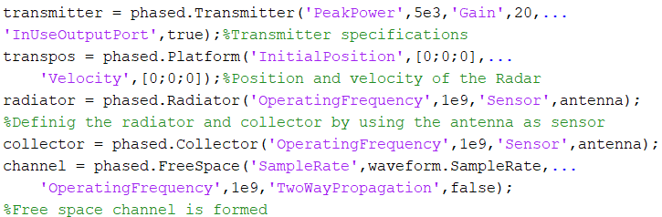

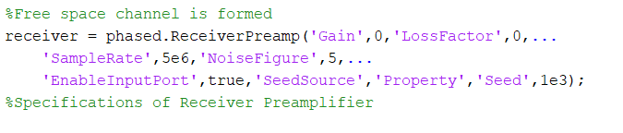

It is important to note here that we are using a different waveform and a different operating frequency here.

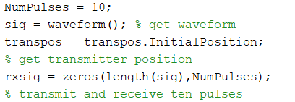

We are using ten pulses for pulse integration and formation of data matrix.

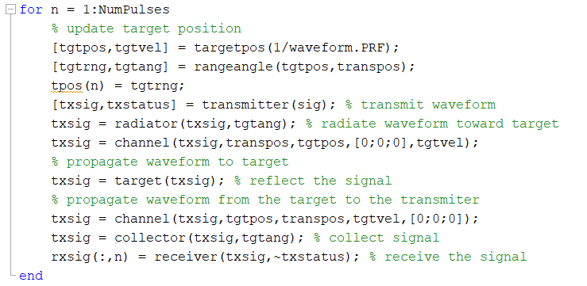

The ‘rxsig’ array will form the data matrix. The for loop just explains the waveform propagation to and from the targets. The ten pulses are collected in the column of the data matrix.

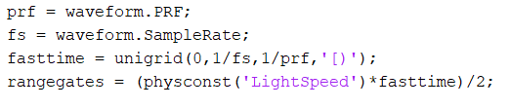

The range gates are created as was explained during simulation results.

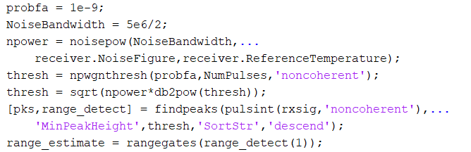

The threshold is defined and any peaks above it are detected as target and is stored in range_detect array. This is now used to give the range estimate of the target as was clearly explained in chapter 3.

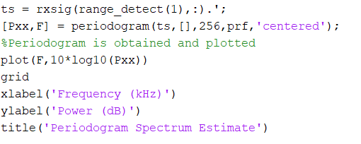

The basic idea behind periodogram is that we obtain the Fast Fourier transform the range gate that detected the target. This is now plotted. The peak in the periodogram plot gives us the doppler frequency which can now be used for calculating the velocity of the target as shown.

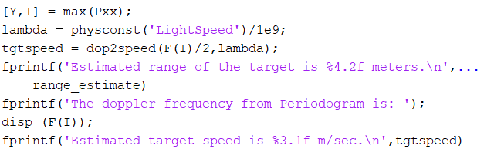

Obtaining the peak of periodogram, we display the doppler frequency and hence calculate the target speed and range.

## Results

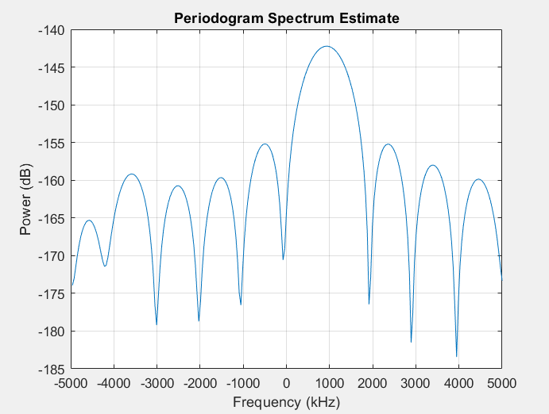

This shows the periodogram with peak of frequency spectrum at 937.50 kHz which corresponds to a velocity of 140.5 m/sec. It matches with the one that we had provided in the target platform block.



The above are the results obtained from MATLAB code. Hence, velocity estimations have been successfully carried out using periodogram method.

# Conclusion

The range and velocity estimations have been successfully obtained using MATLAB and Simulink. But these have been done in somewhat ideal environment. There are many more factors on which the performance of Radar system depends which require much more complex understanding. But the same can be done by using similar software.

Starting from being purely military in use Radar has found varied applications for civil life as well. It is a very potent tool and can be used in a variety of ways. The research into millimetre waves is going to provide us with advance uses of Radar.

The technology is here to stay forever to advance the life of mankind.

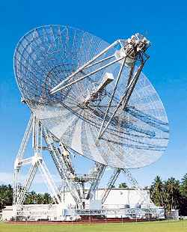

*ALTAIR, A radar system for very precise measurements*

# References

1. Atkins, R., Radar Cross Section Tutorial, 1999 *IEEE* National Radar Conference, 22 April 199.,
2. M. I. Skolnik, Introduction to RADAR Systems, New York: McGraw-Hill, 2001.
3. Vilas s bagad,et al, Microwave and RADAR Engineering, 2008.
4. F. E. Nathanson, RADAR Design Principles, New York: McGraw-Hill, 1991.
5. Louis N. Ridenour. Radar System Engineering, volume 1 of MIT Radiation Laboratory Series. McGraw-Hill, NewYork, 1947.
6. Panel on Frequency Allocations and Spectrum Protection for Scientifi c Uses, Handbook of Frequency Allocations and Spectrum Protection for Scientifi c Uses, Washington, The National academic press, 2nd edition, 2015.
7. David Jenn, “Plasma Antennas: Survey of Techniques and Current State of the Art,” NPS Technical Report NPS-CRC-03-01, September 2003.
8. A. S. Kiran Kumar, “Significance of RISAT-1 in ISRO’s Earth Observation Programme” Current Science, Vol. 104,No. 4, 25 February 2013.
9. <http://www.digitaltrends.com/computin-g/new-satellite-images-shed-light-on-the-7-8-magnitude-nepal-earthquake/>.
10. Skolnik, M., Introduction to Radar Systems, New York, McGraw-Hill, 3rd Edition, 2001.
11. Barton, D. K., Modern radar System Analysis, Norwood, Mass., Artech House, 1988
12. <https://in.mathworks.com/help/phased/ug/radar-equation.html>
13. <https://in.mathworks.com/help/phased/ug/doppler-shift-and-pulse-doppler-processing.html>
14. <https://in.mathworks.com/help/phased/examples/designing-a-basic-monostatic-pulse-radar.html>
15. <https://in.mathworks.com/videos/modeling-and-simulating-radar-systems-using-matlab-and-simulink-81966.html?elqsid=1590804973736&potential_use=Student>
16. <https://in.mathworks.com/videos/design-and-verify-rf-transceivers-for-radar-systems-81990.html?elqsid=1590805489105&potential_use=Student>
17. <https://fas.org/man/dod-101/navy/docs/es310/radarsys/radarsys.htm>
18. <https://www.tutorialspoint.com/radar_systems/radar_systems_pulse_radar.htm>
19. <https://www.electronics-notes.com/articles/radio/radio-receiver-sensitivity/what-is-noise-figure-measurement-calculation-formula.php>
20. <https://in.mathworks.com/help/phased/ref/radarequationcalculator-app.html>
21. <https://en.wikipedia.org/wiki/Radar_signal_characteristics>
22. <https://courses.cs.washington.edu/courses/cse466/15au/pdfs/lectures/Sampling.pdf>
23. <https://faculty.nps.edu/jenn/Seminars/RadarFundamentals.pdf>
24. <https://www.britannica.com/technology/radar/Doppler-weather-radar>
25. <http://dsp-book.narod.ru/RSAD/C1828_PDF_C03.pdf>
26. <https://in.mathworks.com/help/phased/radar-and-ew-systems.html>
27. <https://udrc.eng.ed.ac.uk/sites/udrc.eng.ed.ac.uk/files/attachments/Introduction%20Radar%20signal%20processing.pdf>
28. <https://www.youtube.com/watch?v=EsKdiyCHOik>
29. <https://www.youtube.com/watch?v=z7X6jgFnB6Y>
30. <https://www.alamy.com/stock-photo/air-traffic-control-radar.html>
31. <https://www.researchgate.net/publication/317427496_RADAR_and_its_Applications/link/593a6c57aca272bcd1ea1c40/download>
32. Balanis, C. A., Antenna Theory: Analysis and design, 2nd Edition, New York, Wiley, 1997
33. Mailloux, R. J., Phased Array Antenna Handbook, Norwood, Mass., Artech House, 1994.
34. Nathanson, F. E., Radar Design Principles, New York, McGraw-Hill, 2nd Edition, 1991
35. Eastwood, E., Radar Ornithology, London, Methuen, 1967.
36. Toomay, J. C., Radar Principles for the Non-Specialist, New York, Van Nostrand Reinhold, 1989.